* 1. Graphical user interface, application, Teams

     Description automatically generated
     1. Created file in VS code.
  2. 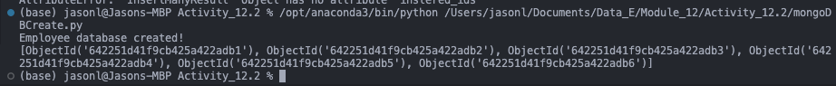
     1. Showing created database and the returned object ids.
  3. Text

     Description automatically generated
     1. Successfully created the findone file
  4. 
     1. Screenshot of returned object ID for lastname Rigby.
  5. Text

     Description automatically generated
     1. Showing creation of findmany file
  6. 
     1. Showing all entries with lastname smith
  7. Text

     Description automatically generated
     1. Created mongoDBUpdateOne.py file
  8. Text

     Description automatically generated with low confidence
     1. Rose is now age 32
  9. Graphical user interface, text, application

     Description automatically generated
     1. Created file for updating many
  10. Text

      Description automatically generated
      1. Showing updated entries with department if their last name was smith.
  11. Graphical user interface, text, application

      Description automatically generated
      1. Successfully created file for delete one.
  12. Text

      Description automatically generated with medium confidence
      1. Shows deleted entry with last name rose
  13. Graphical user interface, text, application

      Description automatically generated
      1. Successfully created file for delete many
  14. 
      1. Shows deleted entries with last name smith